Date: 6-November-2020
Participant Name: Nafis Ahmad Department: O&M
Training Title: Speaker/s:

I . Please Read Carefully: Please give your rating on the scale of 10.

  10 | 9
  8 | 7 | 6
  5 | 4 | 3
  2 | 1 | 0
←---------------------Tick mark in relevant boxes--------------------→

1. Structure: Program Very well Planned Well Planned Less Planned No Planning
√

2. Induction Material Very Relevant Relevant Less Relevant Not Relevant
√

3. Speakers Very Effective Effective Less Effective Not Effective
√

4. Speakers Interaction Excellent Very Good Just OK Poor
√

5. Practical Application Highly Applicable Useful Less Useful Not Useful
of the Training Prog
√

6. Usefulness of Prog Very Useful Useful Less Useful Not Useful
√

7. Program
Arrangements Excellent Very Good Just OK Poor
√

8. Overall impression Very beneficial Beneficial Less Beneficial No Beneficial
√

II Which Content of the Induction Training you found:
Most Useful Least Useful
None.

III Your suggestions /Comments for further improvement : Availability of proper study material will be really helpful.The pdf that was sent by mail is very brief.

Signature & Date
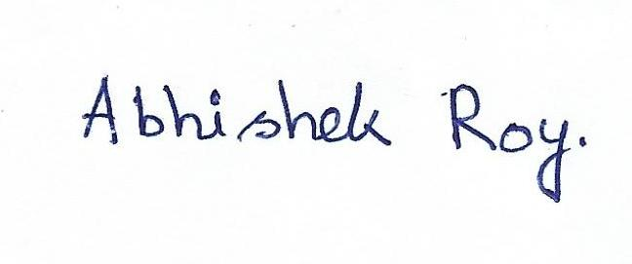
14th july,2020

